**Mobile Application Development**

**Lab Assignments 2-6**

1. Program to design an app to place a text view, edit view in a constraint layout. Provide toast greeting message.
2. Program to design an app to place two image views and toast messages.
3. Program to create a 2 edit views, a text view and two text buttons. On click of first button display a message hello from button1 on text view and onclick of second button display hello from button2 on text view.
4. Program to create an image button and toast message display what image it is.
5. Program to include toggle buttons and a text button display appropriate toast messages.
6. Program to create an app with a switch and a button. Display appropriate toast messages.
7. Program to change the background of the layout on click of buttons
8. Design your own app in constraint layout that should include the following:

Textview,

image view,

Edittext,

Textbutton

Image button

Toggle button

Switch and

also change background of you app.

App should contain toast messages and onclick event should be included..

Combining all questions into 2 apps:

**activity_main.xml:**

<?xml version="1.0" encoding="utf-8"?>

<androidx.constraintlayout.widget.ConstraintLayout xmlns:android="http://schemas.android.com/apk/res/android"

xmlns:app="http://schemas.android.com/apk/res-auto"

xmlns:tools="http://schemas.android.com/tools"

android:layout_width="match_parent"

android:layout_height="match_parent"

tools:context=".MainActivity"

android:background="@color/celeste"

>

<TextView

android:id="@+id/textView4"

android:layout_width="wrap_content"

android:layout_height="wrap_content"

android:text="Mini Calculator"

android:textSize="30sp"

app:layout_constraintBottom_toBottomOf="parent"

app:layout_constraintHorizontal_bias="0.497"

app:layout_constraintLeft_toLeftOf="parent"

app:layout_constraintRight_toRightOf="parent"

app:layout_constraintTop_toTopOf="parent"

app:layout_constraintVertical_bias="0.082" />

<Button

android:id="@+id/buttonAdd"

android:layout_width="wrap_content"

android:layout_height="wrap_content"

android:onClick="addFn"

android:text="+"

android:textSize="30sp"

android:backgroundTint="@color/gunmetal"

app:layout_constraintBottom_toBottomOf="parent"

app:layout_constraintEnd_toEndOf="parent"

app:layout_constraintHorizontal_bias="0.3"

app:layout_constraintStart_toStartOf="parent"

app:layout_constraintTop_toTopOf="parent"

app:layout_constraintVertical_bias="0.5" />

<Button

android:id="@+id/buttonSub"

android:layout_width="wrap_content"

android:layout_height="wrap_content"

android:onClick="subFn"

android:text="-"

android:textSize="30sp"

android:backgroundTint="@color/gunmetal"

app:layout_constraintBottom_toBottomOf="parent"

app:layout_constraintEnd_toEndOf="parent"

app:layout_constraintHorizontal_bias="0.674"

app:layout_constraintStart_toStartOf="parent"

app:layout_constraintTop_toTopOf="parent" />

<Button

android:id="@+id/buttonMul"

android:layout_width="wrap_content"

android:layout_height="wrap_content"

android:onClick="mulFn"

android:text="*"

android:textSize="30sp"

android:backgroundTint="@color/gunmetal"

app:layout_constraintBottom_toBottomOf="parent"

app:layout_constraintEnd_toEndOf="parent"

app:layout_constraintHorizontal_bias="0.3"

app:layout_constraintStart_toStartOf="parent"

app:layout_constraintTop_toTopOf="parent"

app:layout_constraintVertical_bias="0.636" />

<Button

android:id="@+id/buttonDiv"

android:layout_width="wrap_content"

android:layout_height="wrap_content"

android:onClick="divFn"

android:text="/"

android:textSize="30sp"

android:backgroundTint="@color/gunmetal"

app:layout_constraintBottom_toBottomOf="parent"

app:layout_constraintEnd_toEndOf="parent"

app:layout_constraintHorizontal_bias="0.674"

app:layout_constraintStart_toStartOf="parent"

app:layout_constraintTop_toTopOf="parent"

app:layout_constraintVertical_bias="0.636" />

<EditText

android:id="@+id/num1txt"

android:layout_width="wrap_content"

android:layout_height="wrap_content"

android:ems="10"

android:hint="Enter number 1"

android:inputType="number"

app:layout_constraintBottom_toBottomOf="parent"

app:layout_constraintEnd_toEndOf="parent"

app:layout_constraintHorizontal_bias="0.477"

app:layout_constraintStart_toStartOf="parent"

app:layout_constraintTop_toTopOf="parent"

app:layout_constraintVertical_bias="0.225" />

<EditText

android:id="@+id/num2txt"

android:layout_width="wrap_content"

android:layout_height="wrap_content"

android:ems="10"

android:hint="Enter number 2"

android:inputType="number"

app:layout_constraintBottom_toBottomOf="parent"

app:layout_constraintEnd_toEndOf="parent"

app:layout_constraintHorizontal_bias="0.477"

app:layout_constraintStart_toStartOf="parent"

app:layout_constraintTop_toTopOf="parent"

app:layout_constraintVertical_bias="0.346" />

<TextView

android:id="@+id/outputtxt"

android:layout_width="wrap_content"

android:layout_height="wrap_content"

android:text="Result"

android:textSize="36dp"

app:layout_constraintBottom_toBottomOf="parent"

app:layout_constraintEnd_toEndOf="parent"

app:layout_constraintHorizontal_bias="0.498"

app:layout_constraintStart_toStartOf="parent"

app:layout_constraintTop_toTopOf="parent"

app:layout_constraintVertical_bias="0.814" />

</androidx.constraintlayout.widget.ConstraintLayout>

**Activity_main.xml:**

package com.example.myapp;

import androidx.appcompat.app.AppCompatActivity;

import android.os.Bundle;

import android.view.View;

import android.widget.Button;

import android.widget.EditText;

import android.widget.TextView;

import android.widget.Toast;

public class MainActivity extends AppCompatActivity {

private EditText num1, num2;

public void addFn(View view) {

num1 = (EditText) findViewById(R.id.num1txt);

num2 = (EditText) findViewById(R.id.num2txt);

int a = Integer.parseInt((num1.getText().toString()));

int b = Integer.parseInt((num2.getText().toString()));

int result = a+b;

TextView outputtxt = (TextView) findViewById(R.id.outputtxt);

outputtxt.setText("Addition is: "+result);

Toast.makeText(getApplicationContext(),"Addition is: "+result, Toast.LENGTH_LONG).show();

}

public void subFn(View view) {

num1 = (EditText) findViewById(R.id.num1txt);

num2 = (EditText) findViewById(R.id.num2txt);

int a = Integer.parseInt((num1.getText().toString()));

int b = Integer.parseInt((num2.getText().toString()));

int result = a-b;

TextView outputtxt = (TextView) findViewById(R.id.outputtxt);

outputtxt.setText("Subtraction is: "+result);

Toast.makeText(getApplicationContext(),"Subtraction is: "+result, Toast.LENGTH_LONG).show();

}

public void mulFn(View view) {

num1 = (EditText) findViewById(R.id.num1txt);

num2 = (EditText) findViewById(R.id.num2txt);

int a = Integer.parseInt((num1.getText().toString()));

int b = Integer.parseInt((num2.getText().toString()));

int result = a*b;

TextView outputtxt = (TextView) findViewById(R.id.outputtxt);

outputtxt.setText("Multiplication is: "+result);

Toast.makeText(getApplicationContext(),"Multiplication is: "+result, Toast.LENGTH_LONG).show();

}

public void divFn(View view) {

num1 = (EditText) findViewById(R.id.num1txt);

num2 = (EditText) findViewById(R.id.num2txt);

float a = Integer.parseInt((num1.getText().toString()));

float b = Integer.parseInt((num2.getText().toString()));

float result = a/b;

TextView outputtxt = (TextView) findViewById(R.id.outputtxt);

outputtxt.setText("Division is: "+result);

Toast.makeText(getApplicationContext(),"Division is: "+result, Toast.LENGTH_LONG).show();

}

@Override

protected void onCreate(Bundle savedInstanceState) {

super.onCreate(savedInstanceState);

setContentView(R.layout.activity_main);

}

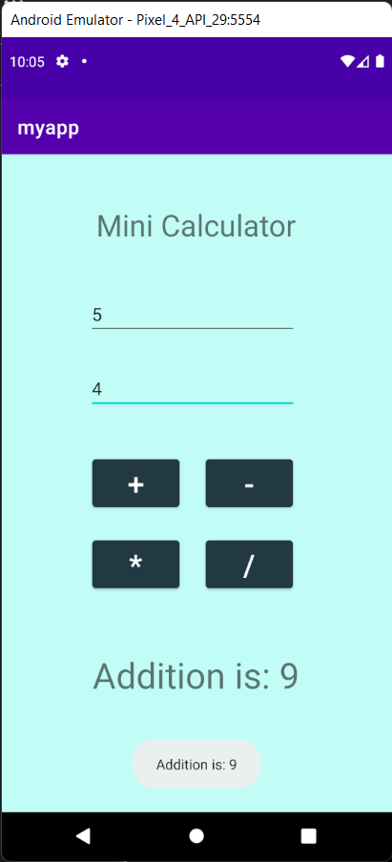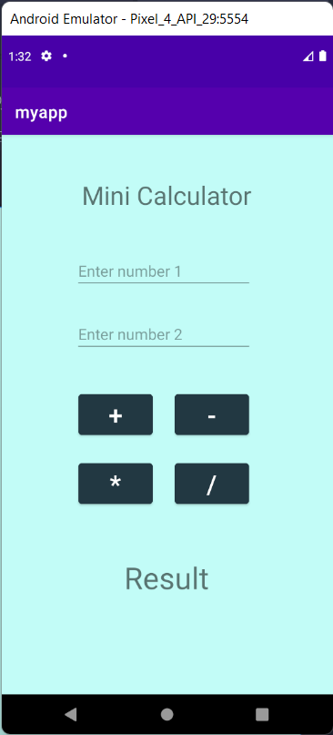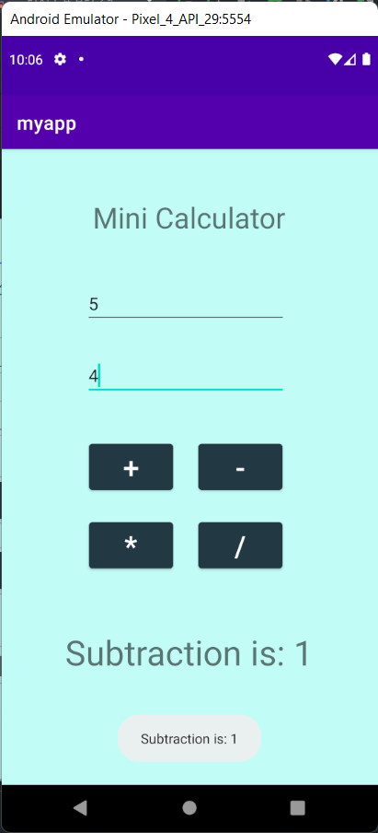

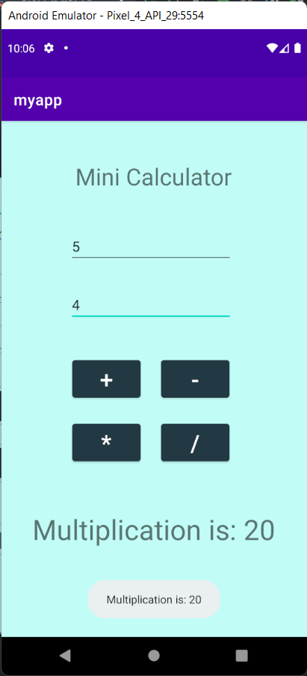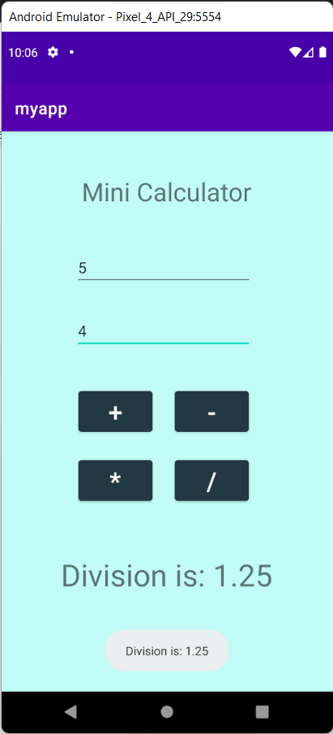

activity_main.xml:

<?xml version="1.0" encoding="utf-8"?>

<androidx.constraintlayout.widget.ConstraintLayout xmlns:android="http://schemas.android.com/apk/res/android"

xmlns:app="http://schemas.android.com/apk/res-auto"

xmlns:tools="http://schemas.android.com/tools"

android:id="@id/layout"

android:layout_width="match_parent"

android:layout_height="match_parent"

tools:context=".MainActivity">

<TextView

android:id="@+id/textView"

android:layout_width="wrap_content"

android:layout_height="wrap_content"

android:text="BMSCE"

android:textSize="50sp"

app:layout_constraintBottom_toBottomOf="parent"

app:layout_constraintLeft_toLeftOf="parent"

app:layout_constraintRight_toRightOf="parent"

app:layout_constraintTop_toTopOf="parent"

app:layout_constraintVertical_bias="0.157" />

<Button

android:id="@+id/btn1"

android:layout_width="136dp"

android:layout_height="63dp"

android:text="MAKE COLOR"

app:layout_constraintBottom_toBottomOf="parent"

app:layout_constraintEnd_toEndOf="parent"

app:layout_constraintHorizontal_bias="0.498"

app:layout_constraintStart_toStartOf="parent"

app:layout_constraintTop_toTopOf="parent"

app:layout_constraintVertical_bias="0.522"

tools:ignore="MissingConstraints" />

<Button

android:id="@+id/btn2"

android:layout_width="136dp"

android:layout_height="63dp"

android:text="Randomize"

app:layout_constraintBottom_toBottomOf="parent"

app:layout_constraintEnd_toEndOf="parent"

app:layout_constraintHorizontal_bias="0.498"

app:layout_constraintStart_toStartOf="parent"

app:layout_constraintTop_toTopOf="parent"

app:layout_constraintVertical_bias="0.675"

tools:ignore="MissingConstraints" />

<TextView

android:id="@+id/outputtxt"

android:layout_width="wrap_content"

android:layout_height="wrap_content"

android:text="Result"

android:textSize="36dp"

app:layout_constraintBottom_toBottomOf="parent"

app:layout_constraintEnd_toEndOf="parent"

app:layout_constraintHorizontal_bias="0.498"

app:layout_constraintStart_toStartOf="parent"

app:layout_constraintTop_toTopOf="parent"

app:layout_constraintVertical_bias="0.814" />

<EditText

android:id="@+id/hextext"

android:layout_width="wrap_content"

android:layout_height="wrap_content"

android:ems="10"

android:inputType="textPersonName"

android:text=""

android:hint="Enter hex code without #"

app:layout_constraintBottom_toBottomOf="parent"

app:layout_constraintEnd_toEndOf="parent"

app:layout_constraintHorizontal_bias="0.497"

app:layout_constraintStart_toStartOf="parent"

app:layout_constraintTop_toTopOf="parent"

app:layout_constraintVertical_bias="0.384" />

</androidx.constraintlayout.widget.ConstraintLayout>

MainActivity.java:

package com.example.eventhandling;

import androidx.appcompat.app.AppCompatActivity;

import androidx.constraintlayout.widget.ConstraintLayout;

import android.content.Context;

import android.graphics.Color;

import android.os.Bundle;

import android.view.View;

import android.widget.Button;

import android.widget.EditText;

import android.widget.TextView;

import android.widget.Toast;

import java.util.Random;

public class MainActivity extends AppCompatActivity {

private ConstraintLayout layout;

@Override

protected void onCreate(Bundle savedInstanceState) {

super.onCreate(savedInstanceState);

setContentView(R.layout.*activity_main*);

Button btn1 = (Button) findViewById((R.id.*btn1*));

Button btn2 = (Button) findViewById((R.id.*btn2*));

TextView outputtxt = (TextView) findViewById(R.id.*outputtxt*);

EditText txt = (EditText) findViewById((R.id.*hextext*));

Random random = new Random();

layout = findViewById(R.id.*layout*);

btn1.setOnClickListener((View.*OnClickListener*)(new View.OnClickListener(){

@Override

public void onClick(View v) {

String name = txt.getText().toString();

int color = Color.*parseColor*(name);

layout.setBackgroundColor(color);

outputtxt.setText("Color: " + name);

}

}));

btn2.setOnClickListener((View.*OnClickListener*)(new View.OnClickListener(){

@Override

public void onClick(View v) {

int color = Color.*argb*(255, random.nextInt(256), random.nextInt(256), random.nextInt(256));

String hexColor = "#" + Integer.*toHexString*(color).substring(2);

layout.setBackgroundColor(color);

outputtxt.setText("Color: " +hexColor);

}

}));

}

}

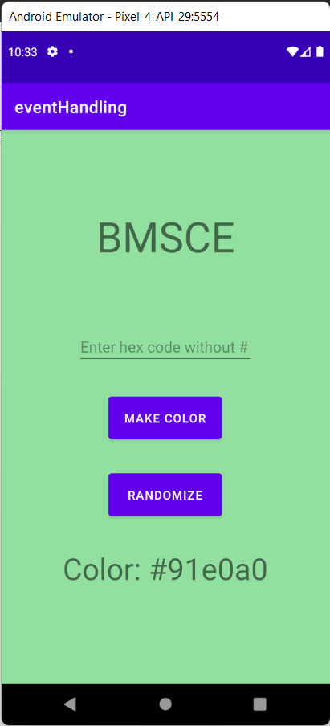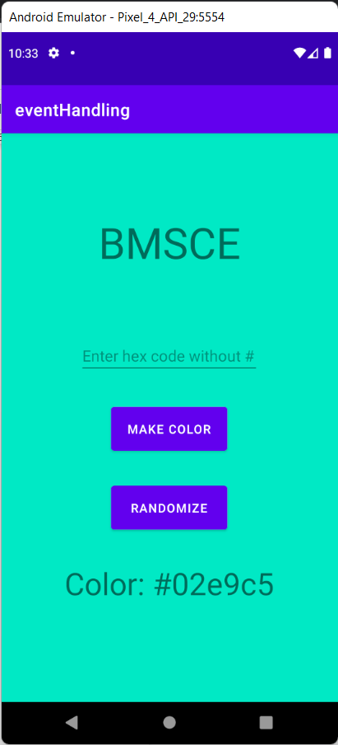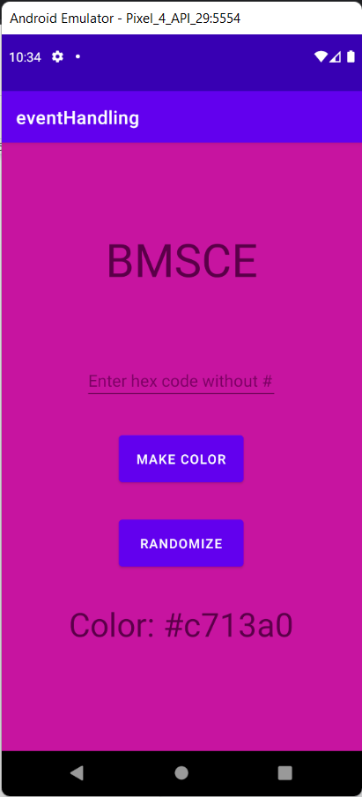

activity_main.xml:

<?xml version="1.0" encoding="utf-8"?>

<!--suppress ALL -->

<androidx.constraintlayout.widget.ConstraintLayout xmlns:android="http://schemas.android.com/apk/res/android"

xmlns:app="http://schemas.android.com/apk/res-auto"

xmlns:tools="http://schemas.android.com/tools"

android:layout_width="match_parent"

android:layout_height="match_parent"

android:layout_margin="20sp"

tools:context=".MainActivity">

<TextView

android:id="@+id/textView"

android:layout_width="261dp"

android:layout_height="74dp"

android:gravity="center"

android:text="What is your name"

android:textSize="25sp"

app:layout_constraintBottom_toBottomOf="parent"

app:layout_constraintEnd_toEndOf="parent"

app:layout_constraintStart_toStartOf="parent"

app:layout_constraintTop_toTopOf="parent"

app:layout_constraintVertical_bias="0.364" />

<TextView

android:id="@+id/textView2"

android:layout_width="294dp"

android:layout_height="90dp"

android:gravity="center"

android:text="@string/textdice"

android:textSize="25sp"

app:layout_constraintBottom_toBottomOf="parent"

app:layout_constraintHorizontal_bias="0.493"

app:layout_constraintLeft_toLeftOf="parent"

app:layout_constraintRight_toRightOf="parent"

app:layout_constraintTop_toTopOf="parent"

app:layout_constraintVertical_bias="0.224" />

<EditText

android:id="@+id/PersonName"

android:layout_width="wrap_content"

android:layout_height="wrap_content"

android:ems="10"

android:hint="Eg. John Wick"

android:inputType="textPersonName"

android:text=""

app:layout_constraintBottom_toBottomOf="parent"

app:layout_constraintEnd_toEndOf="parent"

app:layout_constraintHorizontal_bias="0.496"

app:layout_constraintStart_toStartOf="parent"

app:layout_constraintTop_toTopOf="parent"

app:layout_constraintVertical_bias="0.462" />

<Button

android:id="@+id/button"

android:layout_width="187dp"

android:layout_height="64dp"

android:onClick="diceFn"

android:text="Roll Die"

app:layout_constraintBottom_toBottomOf="parent"

app:layout_constraintEnd_toEndOf="parent"

app:layout_constraintStart_toStartOf="parent"

app:layout_constraintTop_toTopOf="parent"

app:layout_constraintVertical_bias="0.548" />

<TextView

android:id="@+id/outputtxt"

android:layout_width="wrap_content"

android:layout_height="wrap_content"

android:layout_margin="20sp"

android:text="Never gonna give you up"

android:textColor="@color/teal_700"

android:textSize="20dp"

app:layout_constraintBottom_toBottomOf="parent"

app:layout_constraintEnd_toEndOf="parent"

app:layout_constraintHorizontal_bias="0.498"

app:layout_constraintStart_toStartOf="parent"

app:layout_constraintTop_toTopOf="parent"

app:layout_constraintVertical_bias="0.685" />

<ImageView

android:id="@+id/imageView"

android:layout_width="156dp"

android:layout_height="119dp"

app:layout_constraintBottom_toBottomOf="parent"

app:layout_constraintEnd_toEndOf="parent"

app:layout_constraintHorizontal_bias="0.497"

app:layout_constraintStart_toStartOf="parent"

app:layout_constraintTop_toTopOf="parent"

app:layout_constraintVertical_bias="0.027"

app:srcCompat="@drawable/dice" />

<ImageButton

android:id="@+id/imageButton3"

android:layout_width="150dp"

android:layout_height="150dp"

app:layout_constraintBottom_toBottomOf="parent"

app:layout_constraintEnd_toEndOf="parent"

app:layout_constraintHorizontal_bias="0.511"

app:layout_constraintStart_toStartOf="parent"

app:layout_constraintTop_toTopOf="parent"

app:layout_constraintVertical_bias="0.931"

app:srcCompat="@drawable/rick" />

</androidx.constraintlayout.widget.ConstraintLayout>

MainActivity.java:

package com.example.lab5;

import androidx.appcompat.app.AppCompatActivity;

import android.os.Bundle;

import android.view.View;

import android.widget.EditText;

import android.widget.TextView;

import android.widget.Toast;

import java.util.Random;

public class MainActivity extends AppCompatActivity {

private EditText name;

public void diceFn(View view)

{

name = (EditText) findViewById(R.id.PersonName);

String namestr = name.getText().toString();

final int random = new Random().nextInt(7);

TextView dice = (TextView) findViewById(R.id.outputtxt);

if (random!=6){

dice.setText("Hey "+namestr+", you rolled a "+random);

}

else{

dice.setText("Hey "+namestr+", you rolled a "+random+".\nThat's a 6 so you get to Roll again!!");

}

}

@Override

protected void onCreate(Bundle savedInstanceState) {

super.onCreate(savedInstanceState);

setContentView(R.layout.activity_main);

Toast.makeText(getApplicationContext(), "content view setup", Toast.LENGTH_SHORT).show();

}

}

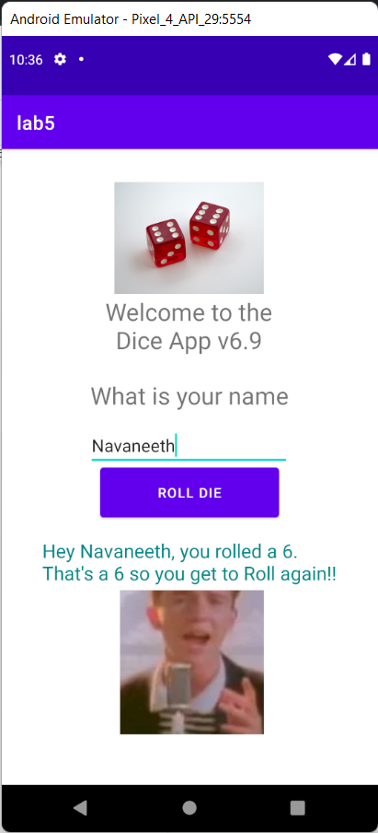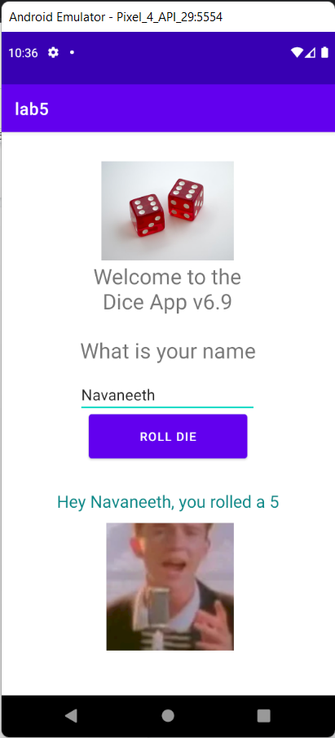

activity_main.xml:

<?xml version="1.0" encoding="utf-8"?>

<androidx.constraintlayout.widget.ConstraintLayout

xmlns:android="http://schemas.android.com/apk/res/android"

xmlns:app="http://schemas.android.com/apk/res-auto"

xmlns:tools="http://schemas.android.com/tools"

android:layout_width="match_parent"

android:layout_height="match_parent"

tools:context=".MainActivity"

android:id="@+id/clvar">

<TextView

android:id="@+id/textView"

android:layout_width="288dp"

android:layout_height="73dp"

android:layout_marginBottom="102dp"

android:gravity="center"

android:text="Toggle Button"

android:textColor="@color/black"

android:textSize="32dp"

app:layout_constraintBottom_toBottomOf="parent"

app:layout_constraintLeft_toLeftOf="parent"

app:layout_constraintRight_toRightOf="parent"

app:layout_constraintTop_toTopOf="parent"

app:layout_constraintVertical_bias="0.14" />

<ToggleButton

android:id="@+id/toggleButton"

android:layout_width="174dp"

android:layout_height="118dp"

android:text="ToggleButton"

android:textOff="Dark Mode"

android:textOn="lightMode"

app:layout_constraintBottom_toBottomOf="parent"

app:layout_constraintEnd_toEndOf="parent"

app:layout_constraintStart_toStartOf="parent"

app:layout_constraintTop_toTopOf="parent"

app:layout_constraintVertical_bias="0.499" />

</androidx.constraintlayout.widget.ConstraintLayout>

MainActivity.java:

package com.example.toggle;

import androidx.annotation.RequiresApi;

import androidx.appcompat.app.AppCompatActivity;

import androidx.constraintlayout.widget.ConstraintLayout;

import android.os.Build;

import android.os.Bundle;

import android.view.View;

import android.widget.TextView;

import android.widget.Toast;

import android.widget.ToggleButton;

public class MainActivity extends AppCompatActivity {

@Override

protected void onCreate(Bundle savedInstanceState) {

super.onCreate(savedInstanceState);

setContentView(R.layout.*activity_main*);

ToggleButton tbtn = (ToggleButton) findViewById(R.id.*toggleButton*);

ConstraintLayout cl = (ConstraintLayout) findViewById(R.id.*clvar*);

TextView txt = (TextView) findViewById(R.id.*textView*);

tbtn.setOnClickListener(new View.OnClickListener() {

@RequiresApi(api = Build.VERSION_CODES.*M*)

@Override

public void onClick(View view) {

if(tbtn.isChecked()){

cl.setBackgroundResource(R.color.*dark*);

txt.setTextColor(getResources().getColor(R.color.*white*, null));

Toast.*makeText*(getApplicationContext(), "Dark Mode Enabled",

Toast.*LENGTH_SHORT*).show();

}

else

{

cl.setBackgroundResource(R.color.*light*);

txt.setTextColor(getResources().getColor(R.color.*purple_700*,

null));

Toast.*makeText*(getApplicationContext(), "Light Mode Enabled",

Toast.*LENGTH_SHORT*).show();

}}

});

}

}

